LV GOSPEL PROJECT / PRESS RELEASE

Joyful Noise
  - Joyful Noise brings gospel voices to a funk groove
LV Gospel Project’s new single arrives on 9 October, ahead of Chapter 1 — Mystery & Majesty, due on 20 November 2026.
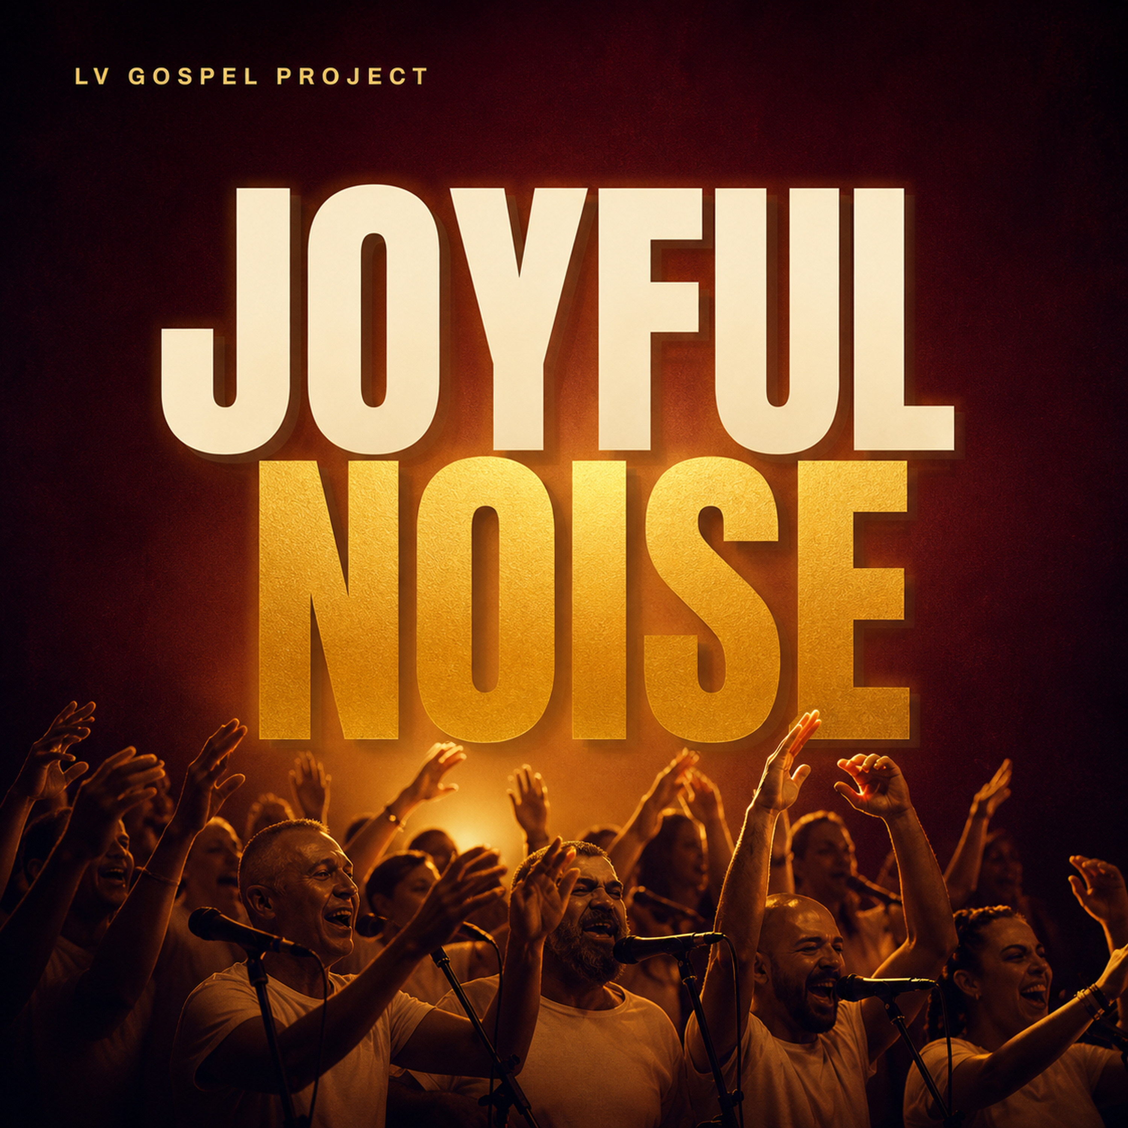
LV Gospel Project will release Joyful Noise on 9 October 2026. The third single ahead of Chapter 1 — Mystery & Majesty centres on the exchange between lead vocals and choir, driven by brass, synths and a funk groove. Sung in English, the song was written by Francesco Maria Gabriele Mocchi, artistic director of the ensemble from Pavia, Italy.
Joyful Noise gives joy a physical expression: clapping, stomping, singing and dancing together. Its language of praise and biblical references remain explicit. Rhythm and the choir’s collective response invite listeners to take part, bringing gospel tradition into dialogue with the band.

Towards Chapter 1
Following Mystery & Majesty, released on 14 August, and With You, released on 11 September, the new single introduces the rhythm-led side of the forthcoming album. Chapter 1 — Mystery & Majesty is due on 20 November 2026 and opens a recording project spanning three chapters.
The ensemble brings together twenty-five voices and eight musicians. Original songwriting and the interplay between choir and band shape a sound rooted in gospel and drawing on funk, soul and contemporary music.

LV Gospel Project
LV Gospel Project took shape in Pavia, Italy, in 2013, growing out of the Corale Universitaria Lorenzo Valla. Led by artistic director Francesco Maria Gabriele Mocchi, the ensemble brings together twenty-five voices and eight musicians. Its original repertoire starts from gospel and draws on funk, soul and contemporary music. Spiritual roots remain part of its identity, while its music welcomes people with a personal relationship to faith or no religious affiliation.
Gospel is our starting point, not a requirement to belong. Music and words resonate: they reach us before any creed. That is where we begin.

Contacts and materials
For interviews, editorial materials and advance listening requests: info@lvgospelproject.it.
https://lvgospelproject.it/en/press
Spotify pre-save is available. The single will be released on 9 October 2026.
https://distrokid.com/hyperfollow/lvgospelproject/joyful-noise

